I assign the radius of som function equal to 0.3, 0.67, 1, 2 and 3.

For K=2

The similarity between the K-means and som are 0.9459029, 0.9439690, 0.9146640, 0.9428658 and 0.9208210.

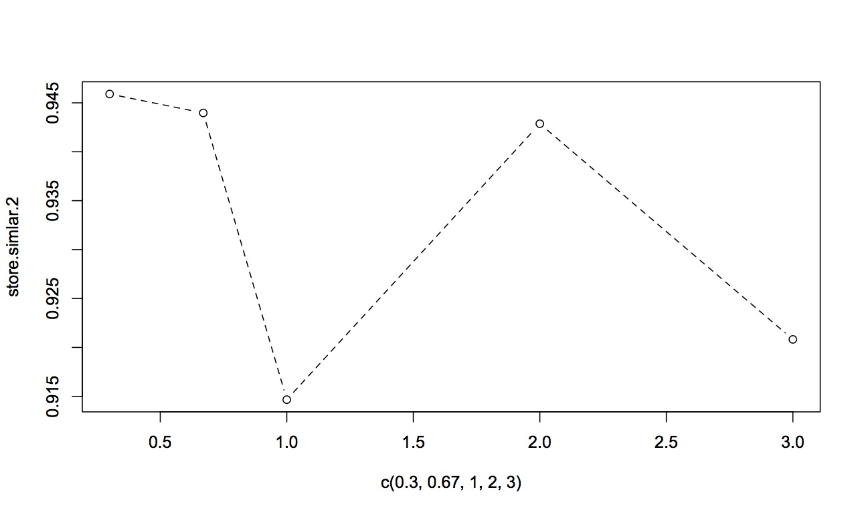

For K=5

The similarity between the K-means and som are 0.6483224, 0.6420039, 0.6369357, 0.6516280 and 0.6381715.

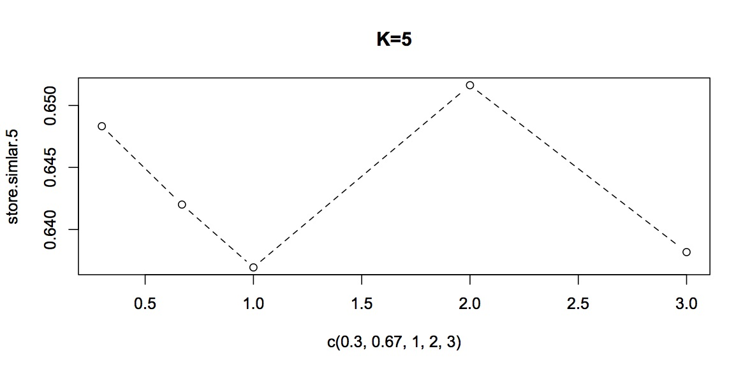

For K=10

The similarity between the K-means and som are 0.7758879, 0.8472734, 0.7798241, 0.7932066 and 0.8037037.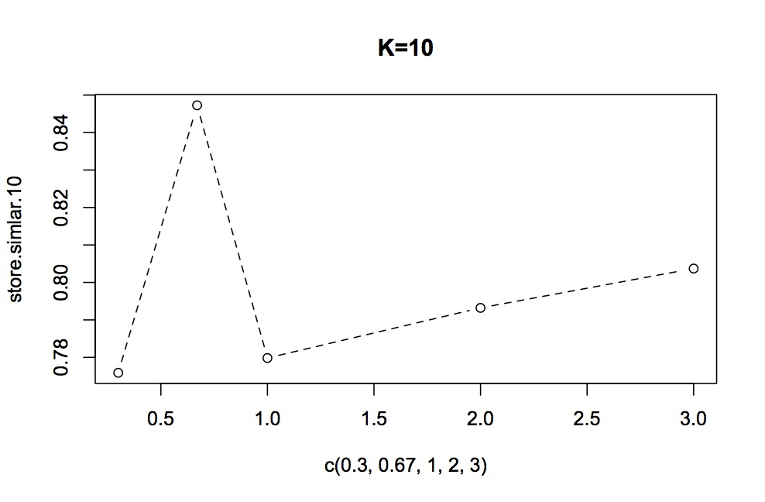

For K=20

The similarity between the K-means and som are 0.8707991, 0.8681026, 0.8597909, 0.8616545 and 0.8536264.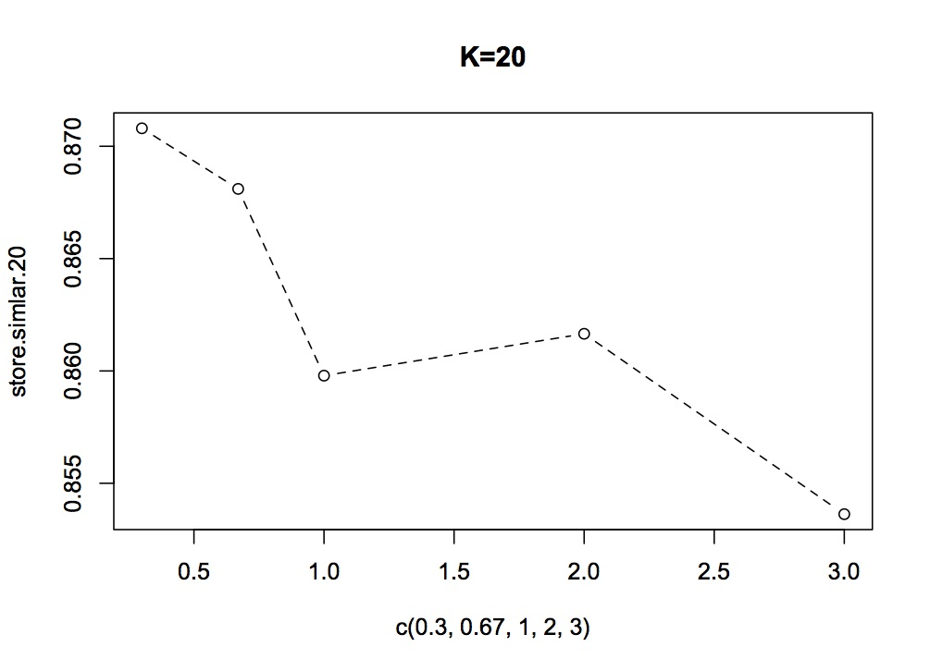

From the result , we can see that when K equals to20 the assumption is rue but for others the assumption is confirmed.